

PROTOCOLS BOOK

Content
Fly Food 3
Ingredients for 13 litres 3
Preparation 3
Ingredients for 2 litres 4
Preparation 4
DNA genomic extraction 5
Squashing buffer 5
DNA genomic extraction with Gentra Puregene Qiagen tissue kit 6
RNA Extraction with Trizol and Ambion Kit 7
DNAse extra treatment 9
Nano-drop quantification 9
Treatment of the quantified RNA 10
cDNA synthesis with NZY first-strand kit 11
Real Time PCR using IQ5 Bio-Rad 12
Protocol for ChIP with agarose beads 18
Day 1: 18
Day 2: 19
Day 3: 20
Mother Solutions: 21
Buffers: 22

Fly Food

Ingredients for 13 litres

562 grs. Glucose
750 grs. Fresh baker yeast
88,5 grs. Bacteriological agar
375 grs. wheat flour
52,5 ml. propionic acid
15 grs. Nipagin

Preparation

Autoclave agar in 2 Erlenmeyer flasks of 2 litres with 1 litre of deionized water each one splitting the amount of agar (44 grs in each Erlenmeyer).
Boil 10 minutes the yeast in a cooking pot with 6 lt. of deionized water. (you must see foam)
Heat 3 litres of deionized water in a cooking pot and add glucose, when the glucose is solved add the autoclaved agar and then the flour.
Mix the solution with a “minipimer” until no lumps in the mixture. Wait 10 minutes boiling and keep mixing with a spoon to avoid flour burn in the bottom of the cooking pot.
Mix the yeast with the glucose/agar/flour mixture in the “papillero”. Be sure that the mixer of the “papillero” is ON.
Wait until the temperature of the mixture down to 65º C.
Add 1 litre of water, with the propionic acid and the nipagin previously mixed.
Put the mixture in tubes or plates.
NOTE: For 13 litres of food preparation you should need about 4h approx. plus the time to put the mixture in the tubes.

Ingredients for 2 litres

86 grs. Glucose
115 grs. Fresh baker yeast
13,5 grs. Bacteriological agar
58 grs. wheat flour
8 ml. propionic acid
2,3 grs. Nipagin

Preparation

Take the yeast from the freezer.
Melt it 10 second in microwave at maximum power.
Cut with a knife the amount you need and freeze again at -20º C the leftover
Put 1,5 litres in a cooking pot and heat.
Add the yeast, the agar the glucose and let it boil during 10 minutes.
It is very important to mix the mixure with a wooden spoon ALL THE TIME to avoid burns in the bottom of the pot.
Add the flour and 500 ml of deioinized water and mix with a “minipimier” until no lumps in the mixture.
Wait 5 minutes boiling mixing with a wooden spoon.
Put the mixture in a 2 litres flask and add water up to 2 litres.
Wait until the temperature down to 65º C (15 – 20 minutes)
Add Nipagin and propionic acid and mix vigorous with a wooden spoon.
Put the mixture in tubes or plates.
NOTE: 2 litres are enough for 30 petri plates
For 2 litres of food preparation you should need about 1h 30minutes aprox.

DNA genomic extraction

Select 1-10 flies using CO₂ pad and put them in an empty labelled Eppendorf tube in ice.
Add one empty extra tube as negative control.
Prepare squashing mix. For 10 flies use 100 µl per tube, for 1 fly use 50µl per tube.
Squashing mix is 99% of squashing buffer + 1% of Proteinase K.
Use the freeze holder to keep the proteinase K out of the freezer. Vortex the proteinase K before adds to the mix.
Vortex the squashing mix before adds to the flies and keep it at room temperature.
Add 30 µl of mix to the flies and smash them with a yellow tip or a blue homogenizer.
Once the flies are well smashed add the rest of the mix and smash them a little more.
Always at room temperature.
Turn on the thermoblock at 96º C
Incubate the tubes at 37º C during 25-30 minutes
Incubate the tubes 2 minutes at 96º C
Spin the tubes
Store at 4º C until use it.
NOTE I: It is recommended to use a dilution 1/10 for PCR reaction
NOTE II: Be sure the flies are very well smashed before add the rest of the mix. No parts of fly should be visible.

Squashing buffer

10mM Tris-HCl pH8,2
1mM EDTA
25mM Na Cl
Filter the solution before store.
Prepare 200 ml. and store in 50 ml Falcon tubes to avoid contamination.

DNA genomic extraction with Gentra Puregene Qiagen tissue kit

Turn on Thermoblock at 65º C
Select 10-30 flies using CO₂ pad and put them in an empty labelled Eppendorf tube in ice.
Add 100 µl of “CELL LYSIS SOLUTION” from the kit to the flies and smash them vigorously with a blue homogenizer, keeping the tube on ice.
Add 500 µl extra of “CELL LYSIS SOLUTION”
Incubate the tube at 65º C 1 hour.
Add 3 µl of “RNAse A SOLUTION” and mix by inversion of the tube 25 times. (The solution must be stored at 4º C)
Incubate the tube at 37º C 35 minutes
Incubate the tube on ice 3 minutes
Add 200 µl of “PROTEIN PRECIPITATION SOLUTION” and vortex 20 second
Centrifuge at 16000 g 3 minutes (If the pellet is not solid incubate 5 minutes on ice and centrifuge again).
Add 600 µl of isopropanol in a new tube
After centrifugation add supernatant to the tube with isopropanol.
Mix by inversion of the tube 50 times.
Centrifuge 1 minute at 16000 g
Discard the supernatant very carefully to keep the pellet
Dry the tube with tissue paper
Add 600 µl of Ethanol 70% and wash the pellet by inversion of the tube 10 times.
Centrifuge 1 minute at 16000 g
Discard supernatant and incubate the tube with the cap open at room temperature on the bench.
Add 50-200 µl of “DNA HYDRATION SOLUTION” or autoclaved Mq water, vortex 5 seconds
Incubate 1 hour at 65º C for DNA rehydration and store at 4º C
NOTE: Pending the amount of flies you use and the concentration you need you can add 50 to 200 µl of DNA Hydration solution

RNA Extraction with Trizol and Ambion Kit

Be sure the 4º C centrifuge is available and at 4º C
Defrost 10X DNAse buffer
Confirm it as available in the lab: Ethanol 70% in RNAse free water, Chloroform, RNAse free water, tips, tubes and homogenizers autoclaved and RNAse free.
Confirm Buffer II of the kit include alcohol.
Clean all surface before start and use globed during the whole procedure, change the globes if you think could be contaminated with RNAse. Remember your skin produce RNAses!
Tissue could be frozen at -80º C or fresh keep it in ice.
For 30-50 flies:
The tube with flies must be clean and labelled without any hole.
Put the tube at room temperature
Add 100 µl of Trizol
Smash the flies with homogenizer very hard, be sure that the flies are completely smashed
Add 400 µl of Trizol and incubate at room temperature 5 minutes
Add 200 µl of Chloroform and shake with your hands vigorously 15 seconds (NO VORTEX!)
Incubate 2-3 minutes at room temperature
Centrifuge at 12.000 rcf at 4º C 15 minutes
During this 15 minutes prepare the clean tubes, the column and the DNAse mix you will need later.
DNAse mix per tube
8 µl Buffer 10x
62 µl RNAse free water
10 µl DNAse (The enzyme must be added in the last moment before use the mix.
80 µl Final Volume
Keep the mix on ice until the moment of use.
After centrifuge the tube will show three phases.
Collect 300-350 µl of the upper supernatant orange colour very carfully. Discard the pink liquid (phenol) and the white mass interface (proteins and others)
Put the orange supernatant in a new tube and add 300-350 µl of Ethanol 70% with RNAse free water and vortex very strong 15 seconds
Invert the tube 3 times and add the 600-700 µl of the tube in a kit column previously inserted in a elute tube (the big ones).
Centrifuge the column with the tube at 12000 rcf 15 seconds at room temperature. Discard the elute but not the tube
Add 350 µl of Buffer I to the column and wait 3-5 minutes
Centrifuge at 12.000 rcf 15 seconds at room temperature
Discard the elute and tube
Put the column in a new elution tube
Add the enzyme to the mix.
Mix up and down to homogenate the mixture
Add 80 µl of the mix to each column very carefully avoiding touch the walls of the column.
Incubate at room temperature 30 minutes
Add 350 µl of Buffer I to the column and wait 3-5 minutes
Centrifuge at 12.000 rcf 15 seconds at room temperature
Discard the elute but conserve the tube
Add 500 µl of Buffer II with alcohol to the column and wait 3-5 minutes
Centrifuge at 12.000 rcf 15 seconds at room temperature
Discard the elute but conserve the tube
Repeat wash with Buffer II
Centrifuge 1 minute at 12.000 r.c.f. at room temperature to discard ethanol
Discard elution tube and put the column in a new RNA tube (included in the kit)
Add 30 µl of RNAse free water (included in the kit) in the midle of the column very carefully
Wait 1 minute and centrifuge 1 minute at max. speed at room temperature
Load the elution in the column again and repeat the previous step.
Discard the column and freeze the RNA at -80º C (use ice bucket to take the sample to the freezer)
Wait 1 hour at -80º C before use.

DNAse extra treatment

After RNA extraction and despite the DNAse treatment, your RNA could be contaminated with DNA. To avoid DNAse contamination we perform an extra DNAse treatment.
After freeze the sample 1 hour at -80º C RNA must be quantified with the Nano-Drop
Confirm the 4º C centrifuge is available and at the correct temperature
Confirm there is Ethanol 100% at -20ºC and RNAse free water
Use always RNAse free tips and autoclaved sterile tubes

Nano-drop quantification

Prepare water (must be the same water you used for the dilution of the sample)
Prepare tips and the samples
Clean properly the pedestal with tissue paper before use
Click the ND1000 V3.5.2 icon and select Nucleic Acid in the first window
Lift the arm and add 2 µl of water to the pedestal, then down the arm and press OK to the pop up window and select “Blank” in the screen of the software. Wait a few seconds the pedestal will make to “clacks” before end the measure.
In the right upper corner is indicated the sample type. Select RNA in this case.
Press “Measure” to quantify the water and be sure that the blank is OK.
Clean the pedestal and add 2 µl of your sample with a new tip.
Press “Measure” and wait a few seconds.
The screen will show you a curve and some data at the right of the windows. Take note of all the values:
Abs
A-260 10mm path
A-280 10mm path
260/280
260/230
ng/µl
The values of 260/280 must be between 1,8 and 2,3 and indicates how pure is your sample
The values of 260/230 must be higher than 260/280 for a clean sample.
Clean the pedestal after use.

Treatment of the quantified RNA

Defrost the DNAse Buffer 10x before quantify in the Nano drop
To prepare the mix you need a RNA concentration of 500 ng/µl or better. If you do not have this concentration, you should do several aliquots and concentrate altogether in a smaller volume.
DNAse Mix
1 µl of DNAse buffer 10x
1 µl of DNAse (added at the end of the mix preparation)
1 to 8 µl of RNA (up to 12 µg maximum)
1 to 7 complete with RNAse free water up to 10 µl
Prepare the mix with the amount of RNA according with the nanodrop measure in individual tubes for each sample and add 1 µl of DNAse enzyme. Up and down the mix for homogenized it.
Incubate 2 hours at room temperature
Add 1 µl of 5M LiCl + 20 µl of Absolute Ethanol stored at -20º C
Incubate 2 hours at -80º C or overnight at -20º C
Centrifuge 15 minutes at max. speed at 4º C
Discard supernatant very very carefully with pipet (REMEMBER RNA PELLET IS TRANSLUCID AND VERY DIFFICULT TO SEE!)
Add 62 µl of Ethanol 70% with RNAse free water at -20º C
Centrifuge 5 minutes at max. speed at 4º C
Discard very carefully supernatant, dry the tube with a tissue paper and incubate 15 minutes on the bench with the cap open.
Resuspend in 8-30 µl of RNAse free water pending of the amount of RNA treated.
Incubate Over Night at -80º C for resuspend and hydrate the RNA.

cDNA synthesis with NZY first-strand kit

Defrost on ice your RNA treated
Book a PCR machine for 1 hour and prepare the following program
25º C – 10 minutes
50º C – 30 minutes
85º C – 5 minutes
4 º C – infinity
Prepare on ice the Mix
10 µl 2x master mix NZYRT
2 µl enzyme mix
xx µl RNA (up to 5 µg recommended 1 µg, if it is possible do not use 500 ng, just in exceptional cases!)
up to final volume 20 µl DEPC-treated water
Prepare the mix in an autoclaved PCR 0,2 ml tube and perform the program described before
After the thermos cycle add 1 µl of NZY RNAse H and incubate at 37º C for 20 minutes
The cDNA is ready. Store at -20º C until use.
NOTE: It is strongly, or even mandatory to make an extra reaction tube withRNA and without enzyme as RT minus control. Because of that you should estimate double amount of RNA and duplicate the mix, one with enzyme and another without it.

Real Time PCR using IQ5 Bio-Rad

Materials:
- cDNA of your samples
- Primers F-R of your target gene
- Primers F-R of your housekeeping gene
- Syber Green
- Mq water
- Real Time Bio-Rad 96 wells plate
- Transparent, adhesive cover Bio-Rad
- Tool to fix correctly the cover to the plate (could be a pen)
- Sterile tips for 1000μl, 300μl, 100μl, 10μl standard and 10μl Diamond-D10
- Sterile centrifuge tubes 1,5ml.
- Pipettes
- Sterile PCR tubes 0,2ml.

Procedure:
- Primer design: To be sure your primers will be successful they must accomplish with the following requirements:
- Fragment amplified 60-150bp
- Fragment amplified with no secondary structures
- Designed in separated exons if it is possible
- 23 +/- 3 nucleotides long
- GC content 45% to 60%
- Tm of primers 60º C to 70º C
- Last 5 nucleotides (3’ terminal) no more than 2 GC
- No more than 4 C or G repetition
- No secondary structures
- No affinity with brother primer
- There is a software on line “Mfold” to check secondary structures
- The primers can be designed using Primer3Plus or PrimerBlast-NCBI available on-line
- www.rtprimerdatabase.org is a database of primers for housekeeping genes, etc.

Note: Before design the housekeeping gene be sure that this gene shows identical expression patterns in different conditions, other way the reference gene will be useless.
At this moment we are using Rpl32 and Actine genes as reference genes and the primers are:
Rpl32_F: CAAGAAGTTCCTGGTGCACAA
Rpl32_R: AAACGCGGTTCTGCATGAG

Actine_RealTime_F: GCGCGGTTACTCTTTCACCA
Actine_RealTime_R: ATGTCACGGACGATTTCACG

- cDNA Preparation: (see page 11) Use always RNA with DNAase treatment, it is very important no trace of DNA in the sample.
- Use 1μg of RNA for RT reaction
- Quantify cDNA before use
- Make aliquots of cDNA before frozen first time to avoid melt/frost process
- Use negative control RT (-)

- Primers verification: Before any Real Time assay is necessary to check the primers with a RT-PCR.
- Do not extract all the RNA samples until the primers have been verified and the standard curve was adjusted.
- Make one RNA extraction only for all the test and once is everything verified proceed with the biological samples.
- Use cDNA of one of the samples diluted 1/10 or 1/5
Pending of the expression level of your gene, usually for a moderate expression1/10 is correct.
- Perform a PCR reaction with 28 cycles at Tm according with your primers
- The agarose gel must shows only one band at the correct size to be sure your primers are specifics. No “primer dimer” is recommended.
- To be absolutely sure is recommended to sequence the product of this PCR to confirm the amplified fragment belongs to your target gene.
- Repeat the operation for your house keeping gene if you do not have information about it.

- Standard curves and control wells: Before test your samples you should check the primer efficiency and the purity of your cDNA and mix, to do this is necessary to perform standard curves for each pair of primers and negative controls (RT-) and no template controls (NTC).
  - Standard curves: should have at least 5 points of dilutions with successive dilutions. All the points must be made in triplicate. Usually the first dilution is 1/10 from the original cDNA and the successive dilutions should be 1/5, that means that your first dilution will be 0,1, and then 0,02; 0,004; 0,0008 and 0,00016
  - Primer dilution: the original concentration of the primers is 100μM according SIGMA instructions for re-hidratation, you should use a dilution 1/10 of this original concentration, mean 10 μM.
  - No Template Control (NTC): This control is to be sure the mix is not contaminated, use three wells for each mix used, to fill with the primer mix and add 2μl of water.
  - Negative control (RT-): This control is to be sure the cDNA is not contaminated, use three wells for each cDNA sample “and mix” to fill with the mix and the RT- tube of your RT reaction.
Very important! The primers efficiency must be between E=90% and E=110%, border minimum acceptable E=85% but is too low!
- Primers Mix: For each well you have to prepare the following quantity of reagent:

- 10μl SybrGreen
- 7,6 μl H₂0
- 0,2 μl Primer-R
- 0,2 μl Primer-F
- 18 μl of mix
- 2 μl cDNA add later
- 20 μl Final Volume
Note: Is recommended to estimate 3 wells extra to avoid lack of mix because pipetting error and foam you could lose part of the mix during the load on the plate.

- Plate design: Before start with the bench is necessary to be sure how you will fill the wells, to do that follow this steps:

- Use a paper pattern like this and fill it with your pencil
 | 1 | 2 | 3 | 4 | 5 | 6 | 7 | 8 | 9 | 10 | 11 | 12
A | 1-A | 2-A | 3-A | 4-A | 5-A | RT-1 | RT-1 | RT-1 | X-1A | X-2A | X-3A | X-4A
B | 1-A | 2-A | 3-A | 4-A | 5-A | RT-2 | RT-2 | RT-2 | X-1A | X-2A | X-3A | X-4A
C | 1-A | 2-A | 3-A | 4-A | 5-A | NTC-A | NTC-A | NTC-A | X-1A | X-2A | X-3A | X-4A
D | 1-B | 2-B | 3-B | 4-B | 5-B | RT-1 | RT-1 | RT-1 | X-1B | X-2B | X-3B | X-4B
E | 1-B | 2-B | 3-B | 4-B | 5-B | RT-2 | RT-2 | RT-2 | X-1B | X-2B | X-3B | X-4B
F | 1-B | 2-B | 3-B | 4-B | 5-B | NTC-B | NTC-B | NTC-B | X-1B | X-2B | X-3B | X-4B
 |  |  |  |  |  | RT-3 | RT-3 | RT-3 | RT-3 | RT-3 | RT-3
 |  |  |  |  |  | RT-4 | RT-4 | RT-4 | RT-4 | RT-4 | RT-4

In this example you have two genes, the reference (A) and the target (B), so you have to perform to separate standard curves for A and for B with different dilutions (1 to 5 for A and for B). After that you have to check your mixes are not contaminated (NTC for A and NTC for B). Youmust be sure your cDNA is correct then you have to make RT- control for each sample, in this case you have 4 samples so you have to check it for each sample and for each mix RT1 to RT4 for blue and for red (each color is for a different mix). Finally the X wells are for your samples, so you have to add the cDNA in each column, three replicas for the reference gene and three for your target gene.

- Set up the IQ5 machine: The design of the plate as well as the program you want to use must be set up in the computer and the machine where you will perform the Real Time PCR reaction.

- Turn on the computer (NOT the machine)
- Click on the Bio-Rad iQ5 icon
- You will see something like this:

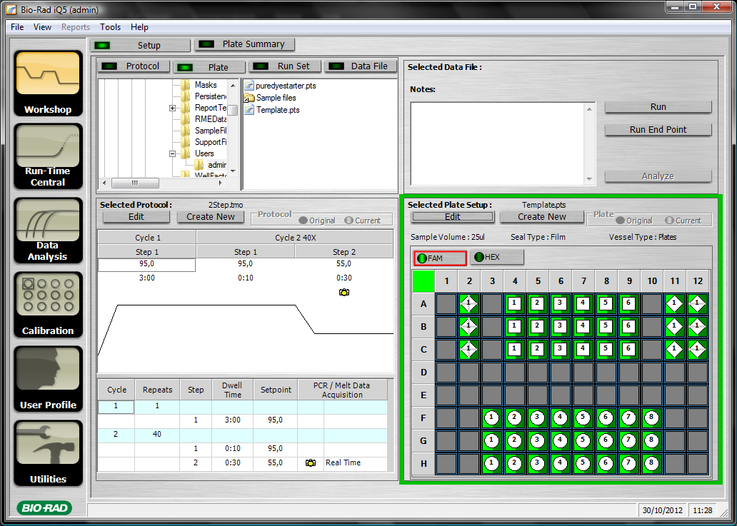

- In PROTOCOL you could set up the program you want to use. Usually is as you can see in the pictures below, but in Pepi Gonzalez folder you could find 50C or 50C-V2 that are all ready programmed and usually works fine.

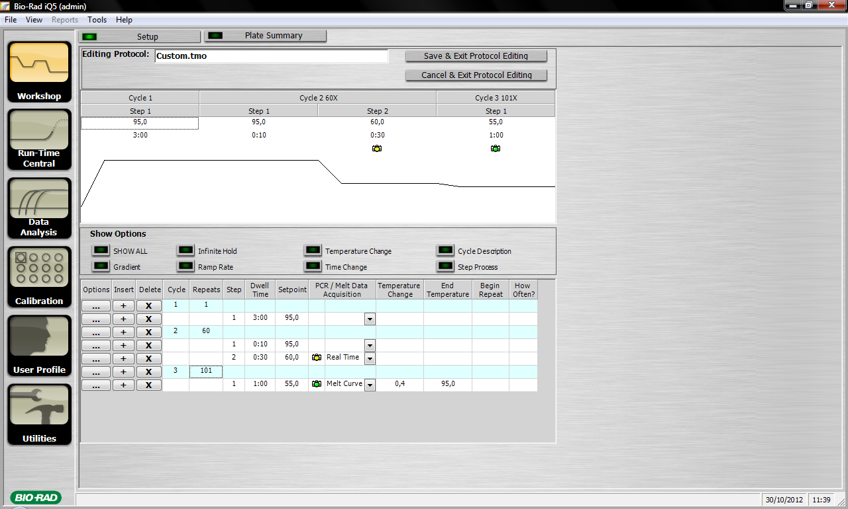

- In PLATE you can set up your plate, you have to do this each time you are going to run a reaction.
- In plate summary you will check your design so you could confirm if everything is correct.
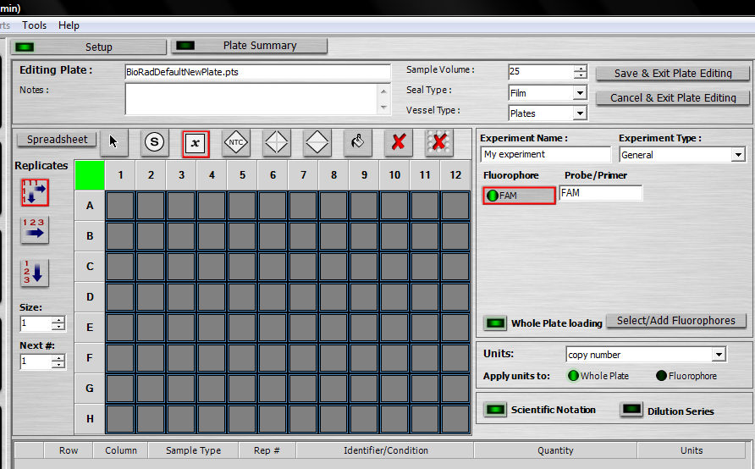
Use this icon for RT- control
Use this icon for standard curves
Use this icon for non-template control
Use this icon for your test samples

If you want to change any well, select fluorophore color and use this icon to delet the selected wells
This color shows which fluorophore you are working with

You have to select one fluorophore for each mix you are going to use and name it. P.e. “gene1” – “gene2”, etc

Click here to set up your dilution series, dilution start and no. of wells
Select your type of sample (curve, control, sample) and click and drag in the plate the replicas for each sample.

- Real time reaction: Finally, you are ready to check the expression! Follow this steps:
  - Store 30 minutes under UV light in the extraction chamber “campana” all the material you will use:
    - Big box of Ice with SyberGreen melting, pipettes, tubes, tips, plates, covers, everything.
  - Prepare the cDNA with the correct dilutions taking in care you will need two μl of cDNA for each sample.
  - Turn ON the computer, the iQ5 Machine and the fluorescent ligh.
  - Change your globes with a new pair
  - Go to the “campana” with your cDNA and primers (on Ice).
  - Prepare the mixes
  - The plate must be on Ice as well as the mixes and the cDNA
  - Fill the plate with the mixes first, remember to vortex every 3 or 6 wells the mix again. If you are using the automatic pipette, vortex the mix before each load. And change the tip each time you change the mix. Remember to load the plate following the below arrows to avoid difference in the replicas.

 | 1 | 2 | 3 | 4 | 5 | 6 | 7 | 8 | 9 | 10 | 11 | 12
A
B
C
D
E
F
G
H

  - Load the wells with cDNA using D-10 Diamand steril tips. You have to use 1 tip for each well.
  - Be sure the cDNA is well mixed before load (up-down with the pipette)
  - If you are using an standard curve, start for the most concentrate cDNA and continue in descendent way.
  - Paste the adhesive cover. Be sure is completely paste to the plate. Help yourself with a tool or a pen to paste every little corner or hole.
  - Once you are absolutely sure the cover is completely paste spin 10 seconds the plate in the centrifuge for plates placed at the Real Time Room.
  - Vortex 30 seconds with the special vortex for plates placed next to the Real Time Machine.
  - Centrifuge 30 seconds at 2000 rpm
  - Place the plate in the machine iQ5, close the lid and go to the computer.
  - Select your plate and protocol and click on “RUN”
  - The machine will start to work and will save the data automatically. You can follow the process if you clic on the icon “RUN-TIME CENTRAL”

- Analyze data: When the reaction finished your data will be stored in the folder you open as user, open the file and use the tools in DATA ANALYSIS icon to manage with your data and check your results.
VERY IMPORTANT! Use always the same threshold for all your plate, do not use the default threshold assigned by the software. Using always the same threshold you can compare different plates.

Protocol for ChIP with agarose beads

Day 1:

Dissect 50 gut (or 40 pairs of ovaries) per tube = 3 antibodies
Dissect in PBS with protease inhibitor cocktail (ROCHE 11 873 580 001)
Keep the guts in 500 µl of Buffer A1 with protease inhibitor
Add formaldehyde up to a final concentration of 1,8% (if M.S. is 16% use 56,25 µl)
For 1% use 31,25µl
Dounce with glass piston without broken the nucleus about 30 times for guts or 12-15 for ovaries
Shake gently in shaker table at Room Temperature (RT)
Total time with formaldehyde 10 minutes.
Stop crosslinking adding glycine up to a final concentration of 125 mM (80 µl)
3 minutes at RT under agitation
Put the samples on ice
Centrifuge the samples 5 minutes at 4000g at 4º C.
Discard supernatant and add 1ml of Buffer A1 with glycine (143 µl)
Use a pipette to resuspend the pellet
Incubate 5 minutes at 4ºC in wheel agitation
Repeat wash in buffer A1 without glycine twice.
Wash once the pellet in lysis buffer without SDS
Resuspend pellet in 200 µl of lysis buffer with SDS
Incubate 1 hour at 4º C in wheel agitator.
Sonication: in the Eppendorf 1,5 ml tube max volume 300 µl. Set level “High” and expose the sample 15-18 times to 30 secs ON and 30 secs OFF rounds and homogenize with pipette after 6 times. For ovaries use 12-14 times. Check in an agarose gel with 4-5 µl of sample the chromatine level after 6 times. The chromatine must be between 500 and 200 bp.
Once the chromatin is according with requirement centrifuge the samples at 14.000 rpm 10 min. at 4º C
Transfer supernatant to a new tube and repeat centrifugation if white pellet is too big.
Take 20 µl of sample and storage at -20º C for input test.
NOTE: At this stage samples could be storage at 4º C over night or frozen at -20º C during several weeks.
Split the 180 µl of chromatine in 3 tubes with 60 µl each one and add to each tube 840µl dilution buffer with protease inhibitor + 75 µl agarose beads and 5 µl of salmon sperm DNA 10mg/ml
Incubate 40 minutes at 4º C on wheel and centrifuge 1’ at 4º C 11.000 g
Pass the supernatant to a new tube carefully, discard pellet.
Add 3 µg of Antibody to each tube according with the test
Incubate ON at 4º C on wheel agitator

Day 2:

Prepare 60 µl of agarose beads + 4 µl of salmon sperm DNA for each tube.
Add 60 µl to each tube of IP and incubate on wheel at 4º C 2,5 – 5.0 hours
Wash the beads at 4º C 5 minutes with rotation on wheel
1 times with 1ml low salt buffer
1 time with 1 ml high salt buffer
1 time with LiCl buffer
2 times with TE buffer
Each wash centrifuge the beads at 4º C , 1 minute 11.000g and discard supernatant carefully.
Prepare at the time of use, during the last wash of TE, the elution buffer: 0.1M NaHCO₃ + 1% SDS.
Add 250 µl Elution buffer to the washed beads.
Vortex during 1 minute and incubate on shaking table at room temperature and incubate 15 minutes.
Centrifuge at 9.000g 1 minute at room temperature
Change supernatant to a new tube.
Add 250 µl of Elution Buffer to the beads again and repeat previous steps.
Combine both supernatants (total volume 500 µl)
To decrosslink the chromatin we need a final concentration of 1% SDS and 200mM NaCl for samples and input. SDS is already in elution buffer so only adding NaCl.
For input 20 µl + 480 µl Elution buffer + 25 µl NaCl 5M
For IP 500 µl + 25 µl NaCl 5M
Decrosslinking incubating 6 hours to overnight at 65º C 300 rpm
If you want you can freeze the samples here

Day 3:

Add Proteinase K (10mg/ml) 2µl in 500 µl of IP (40 µg/ml final). Incubate 1hour at 55º C (could be incubated for more time)
Phenol/Chloroform extraction:
Add 600 µl phenol/Chloroform
Vortex
Centrifuge 14.000 rpm 4º C 3 minutes and change upper phase to a new tube
Add 500 µl of Chloroform and Vortex
Centrifuge 14.000 rpm 4º C 3 minutes and hange upper phase to a new tube
Add two volumes of ethanol 100% + 1/10 of NaAc 3M pH=5,3 + 2 µl glycogen
Incubate 3 hours to OvNg at -20º C
Centrifuge 14.000 rpm 30 minutes 4º C
Discard supernatant carefuly
Wash with 400 µl ethanol 70% cold
Centrifuge 14.000 rpm 10 minutes 4º C
Discard supernatant carefuly
Dry at RT or 37º C 15min. and resuspend pellet in 40-50 µl of water
Quantify the DNA at the nanodrop and run a 2% agarose gel with 3-4 µl

Mother Solutions:

- HEPES 1M (10ml): PM: 238,31 – 2,4g in 10ml H₂O, + NaOH pH=8

- Sodium Butyrate 1M (10ml): PM: 110,09 – 1,1g in 10 ml H₂O

- KCl 1M (20ml): PM: 74,55 – 1,49g in 20 ml H₂O

- Triton x100 10% (10ml): 1 ml in 10 ml H₂O

- NaCl 5M (10ml): PM: 58,44 – 2,92g in 10 ml H₂O

- EDTA 0,5M (10ml): PM: 372,24 – 1,86g in 10 ml H₂O + NaOH pH=8 Ethylenediaminetetraacetic acid disodium salt dihydrate

- EGTA 0,5M (10ml): PM: 380,35 – 1,9g in 10 ml H₂O + NaOH pH=8
  - Ethylene glycol tetraacetic acid

- Deoxycholate of Sodium 10% (10ml): 1,0g in 10 ml + H₂O (4ºC)

- Protease Inhibitor cocktail ROCHE 11 697 498 001: 1 tablet in 1 ml H₂O (store at -20ºC up to 12 weeks. 1 ml can be used in 50ml solution) “mini cocktail 1 tablet is for 10 ml”.

- SDS 20% (10ml): 6g in 30 ml H₂O

- Nonidet NP40 10% (10ml): 1ml in 10 ml H₂O

- Tris-HCl 1M (10ml): PM: 157,60 – 1,57g in 10 ml H₂O

- Tris 1M (50ml): PM: 121,14 – 6,05g in 50ml H₂O

- LiCl 4M (10ml): PM: 42,4 – 1,7g in 10 ml H₂O

- Glycine 1M (10ml): PM: 75,07 – 0,75g in 10 ml H₂O

Buffers:

PBS (400ml) autoclave:
  - 137mM NaCl 3,2g in 400ml H₂0
  - 2,7mM KCl (1,08ml mother solution MS)
  - 10mM Na₂HPO₄: PM: 141,96 – 0,568g in 400 ml H₂0
  - 1,8mM KH₂PO₄: PM: 136,09 – 0,1 g in 400 ml H₂0
  - Mq H₂0 up to 400 ml + HCl pH=7,4

Buffer A1 (50ml):
  - 750 µl HEPES MS (15mM final)
  - 500 µl Sodium Butyrate MS (10mM final)
  - 3 ml KCl MS (60mM final)
  - 2,5 ml Triton x100 MS (0,5% final)
  - 30 µl NaCl MS (15mM final)
  - 1ml cocktail Roche (-20ºC defrost)
  - Mq H₂0 up to 50 ml

Lysis buffer without SDS (50ml):
  - 750 µl HEPES MS (15mM final)
  - 100 µl EDTA MS (1mM final)
  - 50 µl EGTA MS (0,5mM final)
  - 500 µl Sodium Butyrate MS (10mM final)
  - 500 µl Deoxycholate of sodium MS (0,1% final) (4ºC wait melt)
  - 5 ml Triton x100 (1% final)
  - 1,4 ml NaCl MS (140mM final)
  - 1ml cocktail Roche (-20ºC defrost)
  - Mq H₂0 up to 50 ml
Note: Add Deoxycholate “AFTER” Triton to avoid precipitation

Lysis buffer with SDS (50ml):
  - 750 µl HEPES MS (15mM final)
  - 100 µl EDTA MS (1mM final)
  - 50 µl EGTA MS (0,5mM final)
  - 500 µl Sodium Butyrate MS (10mM final)
  - 500 µl Deoxycholate of sodium MS (0,1% final) (4ºC wait melt)
  - 5 ml Triton x100 (1% final)
  - 1,25 ml SDS MS (0,5% final)
  - 2,5 ml N-laurosylsarcosine MS (0,5% final)
  - 1,4 ml NaCl MS (140mM final)
  - 1ml cocktail Roche (-20ºC defrost)
  - Mq H₂0 up to 50 ml

Note: Add Deoxycholate “AFTER” Triton to avoid precipitation

Buffer TE (400ml) autoclave:
  - 0,8 ml EDTA MS (1mM final)
  - 4 ml Tris-HCl MS (10mM final)
  - Mq H₂0 up to 400 ml

ChIP dilution buffer:
  - 0.01% SDS
  - 1.1% Triton X-100
  - 1.2 mM EDTA pH 8.0
  - 16.7 mM Tris-HCl, pH 8.1
  - 167 mM NaCl

Low salt concentration buffer:
  - 0.1 % SDS
  - 1 % Triton X-100
  - 2 mM EDTA pH 8.0
  - 20 mM Tris-HCl, pH 8.1
  - 150 mM NaCl

High salt concentration buffer:
  - 0.1 % SDS
  - 1 % Triton X-100
  - 2 mM EDTA pH 8.0
  - 20 mM Tris-HCl, pH 8.1
  - 500 mM NaCl

LiCl complex wash buffer:
  - 1 % NP40
  - 1 % deoxycholate
  - 1 mM EDTA pH 8.0
  - 10 mM Tris-HCl, pH 8.1
  - 250 mM LiCl

